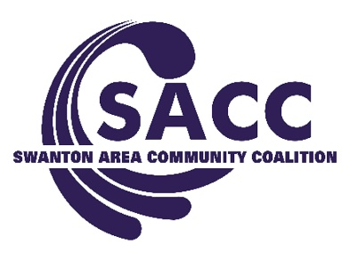
Attendance: Neil Toeppe, Matthew Schneider, Kerri Rochelle, Gary Waterstradt, Ed Strietelmeier, Deb Chany, Rachel Jordan, Adam Berg, Jasmine Kenzie, Abby Sceiere, Andrea Smith, & Jill Fink
Absent: Matt Smith & Colin McQuade

August 1, 2017 Board Meeting Agenda
1.) 2017 Calendar
-Events: Senior Lunch & Learn, Corn Fest, Parent Survey, October DTBD, RRW, Halloween Hoopla, November Town Hall
-Volunteers: 1.)_Gary Waterstradt & 2.) Kerri Rochelle

2.) Organizational:
MHB FY18 Funding Approved
Staffing-We will be taking on a Fall BGSU student for 90 hrs from Sept 11-Nov. 17. SACC made an agreement to be a formal internship location for the BGSU Family Studies Dept for the 2018 Spring semester.
Board Members- Board Approved Marcus Espinoza (NBC Reporter as SACC’s Media Sector-Kerri is officially the Parent Sector Rep). It is understood that based on his work schedule, he will not be able to attend monthly meetings; however, he is still expected to meet monthly individually with staff or others as appropriate and attend all other required events. Group agreed that Cindy from the American Legion should be contacted to see if she is interested in joining the Board. She would be the Civic Sector. Andrea will reach out to her.
Movie Night Review- Pleased with level of involvement, well attended, believed that we don’t have spend a ton of money to get the latest and newest movie to play-we just need to pick a movie that parents want to bring their kids to & pick a different time of year (this was one of the longest days of the year).
TIPS Training (Jill)- Jill and Office Chuck received formalized certification and the training was offered to the Corn Fest
DTBD Outcomes (Adam)- collected ~69 lbs and 22 syringes

3.) Youth Programming Update:
Summer Retention Efforts- Mud Hens Game Aug. 9, held several meetings
5th Quarters- Sept. 22 & Oct. 20- Sponsorship targets: Chick-fil-a & Wendy’s
No Tobacco School Signs-Environmental Strategy- Signs will be taken to the schools at the beginning of the year by youth. Suggested that SACC should link with Marcus and see if he can assist with a press release for this.
Youth Survey 2017/18- Looking at doing it in November or early 2018 (contacted Admin but haven’t heard back)

3.) Education- Medical Marijuana- Will be done at the October meeting. Each meeting moving forward will contain 5-10 mins of education or ‘latest trends’ within the field. That way we are all knowledgeable and we can all be providing the same information when representing SACC in the community.

Open Floor:
Deb suggested that the Board agrees to a membership requirement of contributing to the organization financially. Since we are discussing sustainability, one of the important parts of requesting funding is that the organization can report that 100% of the Trustees are already contributing. This is a requirement for her Board Members with SCAT. She stated that there doesn’t have to be minimum contribution amount; however, each member should give to their capacity. This will be discussed at the next Board Mtg. The group didn’t seem to have an issue with the idea.

Next meeting: September 5th 5:30-6:30

