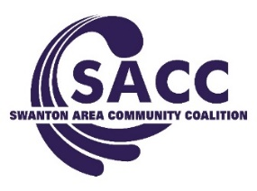

Board Meeting Agenda
December 5, 2017

Attendance: Gary Waterstradt, Colin McQuade, Matt Smith, Lori Jones, Deb Chany, Ed Strietelmeier, Neil Toeppe, Abigail Sciere, Xavier Williams, Andrea Smith & Jill Fink
Excused: Garrett Swank Absent: Matthew Schneider, Kerri Rochelle, Cindi Dickman

- Welcome & Introductions (Gary)

Old Business (Gary)

- Review of Meeting Minutes. 1st: Neil 2nd: Ed Vote: Pass
- Open Floor

New Business

- Organization Update (Gary/Andrea)
  - Sustainability Plan: January Mtg Changed- Jan 10th

- Review of Financial Status-(Neil)
Current Balance: DFC - $3,625.55 MHB - $11,394.13 Reserves - $29,538

- Youth Programming (Jill)

- Updates (Gary/Andrea)
  - Town Hall-(Matt & Andrea)- Jan 25th Collaborate with Matt (Alpha program)- Skyzone Ed for parents/SMS
  - Xmas in Swanton (Xavier)- Very successful this year. A lot more came this year than last yr and they liked the set more this year. More organized this year and happy about the permission slips. Really well too. This year like how it was set up more, liked how the books were set. Lots of stickers. Looked really nice. Advise that santa doesn’t stay as long. Santa until 1:30
  - Prevention Conference (Jill & Andrea)- Was asked to be presenters – round table – split into two, Andrea spoke on the organization at large, while Jill spoke about the youth programming. Received very nice compliments about our organization.
  - Holiday Campaign- Focus on binge drinking, drinking and driving, and having a safe and sober holiday. Running from January 11th – after the New Year. Starting off with Project Bulldogs and then billboards will be up, yard signs will be located at the park, and poll voting will be available daily on social media

- 2017 Year in Review

- Open Floor To Discussion (Gary)

- Adjournment (Gary) 1.) Neil 2.) Deb Vote: Passed

