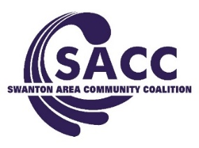

Board Meeting Agenda
January 10, 2018

Attendance: Gary Waterstradt, Lori Jones, Deb Chany, Ed Strietelmeier, Neil Toeppe, Kerri Rochelle, Adam Berg, Andrea Smith & Jill Fink
Excused: Matthew Schneider, Matt Smith, Abigail Sciere, Garrett Swank, Colin McQuade, & Cindi Dickman

- Welcome & Introductions (Gary)

Old Business (Gary)

- Review of Meeting Minutes. 1st: Neil 2nd: Lori Vote: Passed

- Open Floor

New Business

- Review of Financial Status (Neil)
Current Balance: DFC- $214.69 MHB- $14,124.60 Reserve- $28,888

- Youth Updates (Jill) -#ProjectBulldogs Dec 12 passed out t-shirts kids were given the opportunity to talk to their parents, experiences with Rx, etc. Two high school students advocated for the stickers for the sticker shock. The students did amazing.

- Holiday Campaign & Skyzone ALPHA event – January 25th; parents and students will be educated at the beginning (separately). Parents will learn about how to talk to their children about the importance of open communication and students will learn about bullying. Then food will be provided to both, and students will be able to jump for the remaining time. This event will take the place of our usual “town hall”. We are trying something different to get the message out.

- Organizational Planning (Gary Introduce)
Deacon Dzierzawski
2 years remaining DFC (Oct 2020 it ends)
Expansion to Holland/Springfield-
Mentoring Grant- 5 to 12 awards
Possible- state certified, contacts with both boards, can get local and state funding,
NWO hospital survey
Direct service? School based curriculum
Add to mission.
OMAS funding.
We reach to the community and parents to be effective with the youth.

- Open Floor To Discussion (Gary)

- Adjournment (Gary)

